Toy Model 5b

L_Z = mbeta.*(V.*exp(-malpha.*V));

L_V = -mbeta.*Z;

Malpha = 1

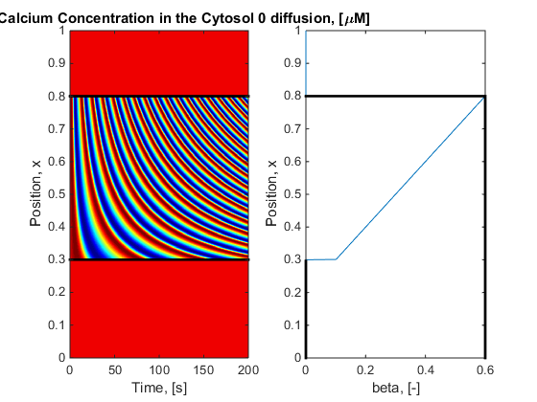

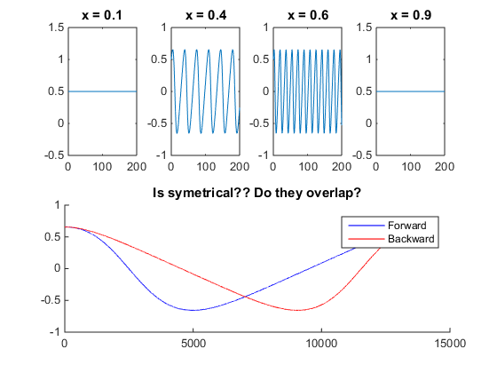

This solution has a slow increase and a rapid decrease (Back heavy wave). So as the period increases it is trying to force the wave up not down as in the goldbeter case.

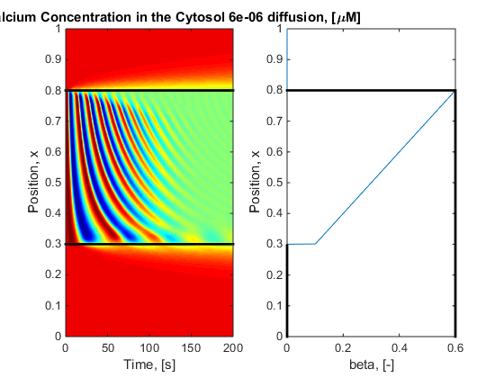

As expected waves are interacting but not protruding

Toy Model 5c

L_Z = mbeta.*(V.*exp(malpha.*V));

L_V = -mbeta.*Z;

No Negative

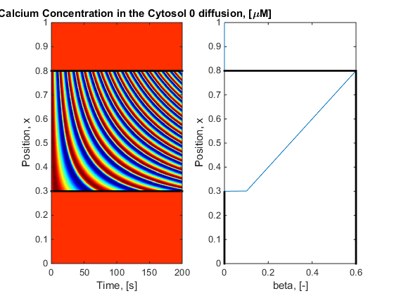

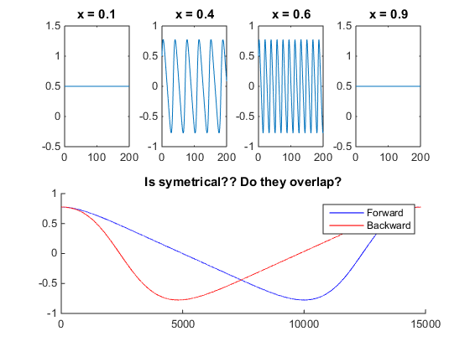

Now have front heavy wave

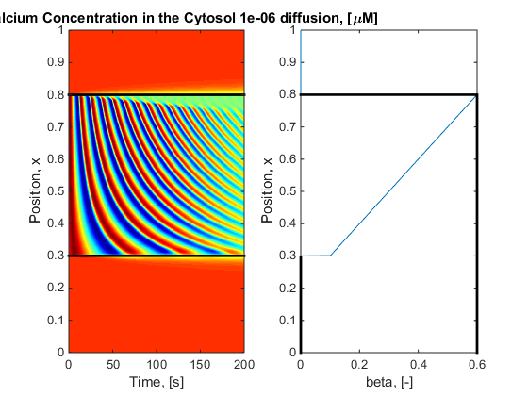

We have positive interaction but no propagation. I think I understand why based on what Rua was saying that this specific toy model doesn’t actually have a good bifurcation diagram such that it has a non-oscillatory region.

Toy Model 5d

malpha = -0.2;

L_Z = -malpha.*V - Z.^3./3 +Z;

L_V = malpha.*Z + mbeta;

Bifurcation:

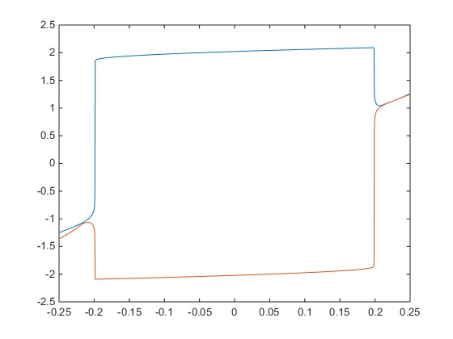

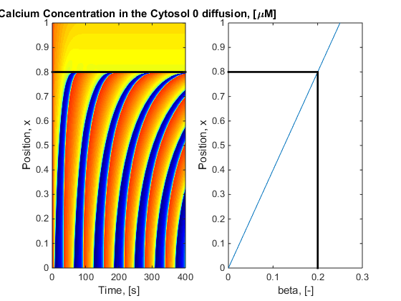

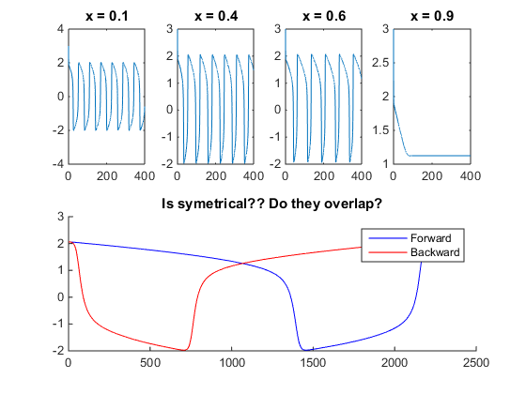

Rapid increase slow decrease ie front heavy. However, the period of relaxation is small thus I don’t expect waves to stop

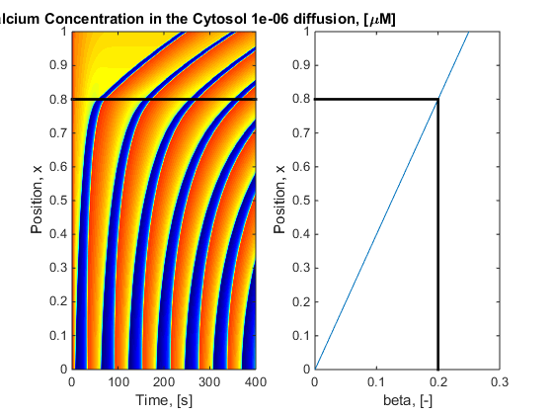

As expected.

Can I flip the concentration wave upside down?

Use alpha = -0.2, B = -0.25:0

Bot heavy

Bot heavy

Top heavy

Top heavy

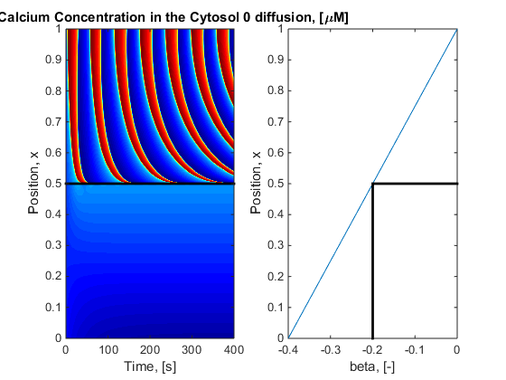

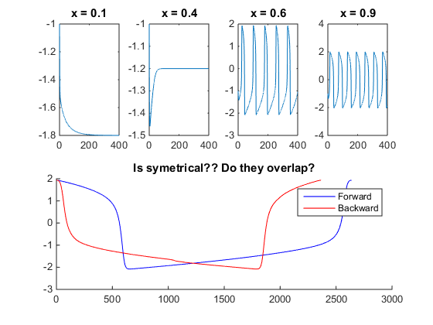

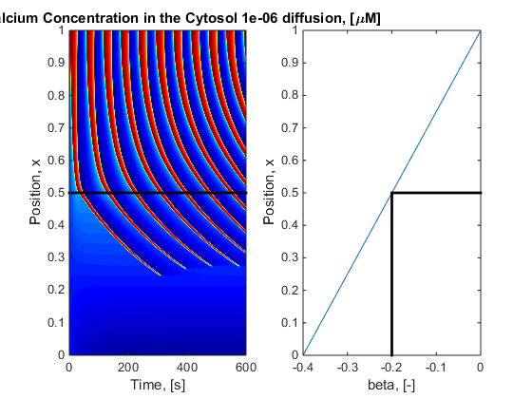

Boom town Protrusion stops!!!!

Note: the wave shape is a rapid increase of slope, a, and the decrease also has the slope, a, therefore the “diffusion in from above = diffusion in from below” statement may not work so well.

